data(LifeCycleSavings)

View(LifeCycleSavings)

install.packages(c("cluster", "factoextra"))

lf <- scale(LifeCycleSavings)

library("factoextra")

res <- get_clust_tendency(lf, 40, graph = TRUE)

# Hopskin statistic

res$hopkins_stat

**Console: 0.2980111**

# Visualize the dissimilarity matrix

print(res$plot)

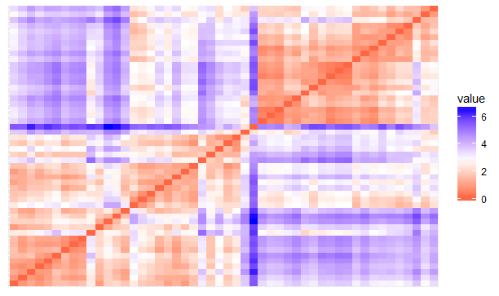

library("cluster")

set.seed(123)

# Compute the gap statistic

gap_stat <- clusGap(lf, FUN = kmeans, nstart = 25,

K.max = 10, B = 500)

**Console: Clustering k = 1,2,..., K.max (= 10): .. done**

**Bootstrapping, b = 1,2,..., B (= 500) [one "." per sample]:**

**.................................................. 50**

**.................................................. 100**

**.................................................. 150**

**.................................................. 200**

**.................................................. 250**

**.................................................. 300**

**.................................................. 350**

**.................................................. 400**

**.................................................. 450**

**.................................................. 500**

# Plot the result

library(factoextra)

fviz_gap_stat(gap_stat)

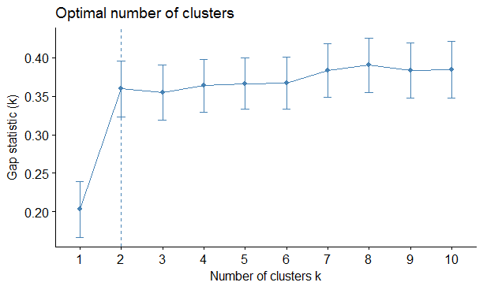

# Compute k-means

set.seed(123)

km.res <- kmeans(lf, 2, nstart = 25)

head(km.res$cluster, 20)

**Console:** Australia Austria Belgium Bolivia Brazil Canada Chile

2 2 2 1 1 2 1

China Colombia Costa Rica Denmark Ecuador Finland France

1 1 1 2 1 2 2

Germany Greece Guatamala Honduras Iceland India

2 2 1 1 2 1

# Visualize clusters using factoextra

fviz_cluster(km.res, LifeCycleSavings)

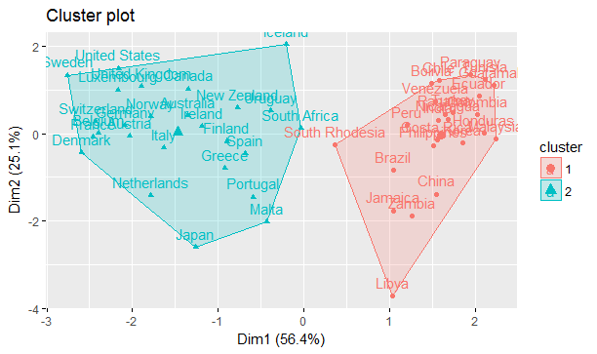

# Enhanced hierarchical clustering

res.hc <- eclust(lf, "hclust") # compute hclust

**Console:** Clustering k = 1,2,..., K.max (= 10): .. done

Bootstrapping, b = 1,2,..., B (= 100) [one "." per sample]:

.................................................. 50

.................................................. 100

fviz_dend(res.hc, rect = TRUE) # dendrogam

